Rising Math 7
Summer Assignment
2018-2019

Name: _____________________________________________________________________________

Please complete this work over summer and return to your Math 7 teacher the first week of class.

Complete a little each week.

SHOW ALL YOUR MATHEMATICAL THINKING!
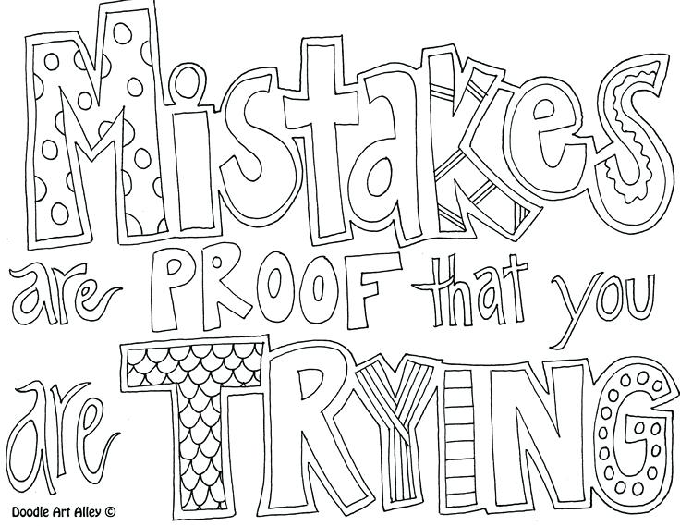

The websites below contain tutorials, practice, and quizzes for review:

http://www.regentsprep.org
http://www.math.com
https://www.mathgoodies.com/lessons
http://education.jlab.org/solquiz/
https://www.khanacademy.org/math/cc-sixth-grade-math

Week 1 – Numeric Expressions

Simplify each expression using the order of operations (GEMDAS).
- $3(5)+14÷2$ | - $\frac{(5⋅8)}{10}$ | - $3⋅6-4⋅4$
- $(8-3+1)÷2$ | - $\frac{(8-3)}{5⋅3}$ | - $16-4$ x 3

Evaluate the expressions using absolute value.
- $|-7|$ | - $\left|15\right|$ | - $|-3.5|$

Compare and Order Integers. Fill in the blank with a “<” or a “>”
10. 0 ____ $-5$ | 11. 10 ____ $-11$ | 12. $-9$____ 6

Week 2 – Fractions, Decimals, and Percents

Multiply or divide the fractions.

13. $\frac{2}{3}⋅\frac{9}{16}$ | 14. $\frac{4}{15}⋅\frac{5}{8}$
15. $\frac{1}{4}÷\frac{3}{8}$ | 16. $\frac{3}{4}÷\frac{2}{3}$

Find the equivalent decimal and percent for each fraction.

17. $\frac{2}{5}$ | 18. $\frac{3}{8}$ | 19. $\frac{1}{4}$
Decimal: | Decimal: | Decimal:
Percent: | Percent: | Percent:

Write the fractions from above in order from greatest to least.
20.
___________, ___________, ___________

Week 3 – Properties of Real Numbers

Use the distributive property to rewrite the expression without parentheses.
21. $4\left(2+9\right)$ | 22. $2\left(6-5\right)$ | 23. $5(20+7)$
Identify which property is being used in each question:
Commutative Property of Addition | 24. $8\left(0\right)=0$
Commutative Property of Multiplication | 25. $5∙1=5$
Associative Property of Addition | 26. $7+\left(2+9\right)=\left(7+2\right)+9$
Associative Property of Multiplication | 27.$2∙\frac{1}{2}$=1
Identity Property of Addition | 28. $5+3=3+5$
Identity Property of Multiplication | 29. $2∙6=6∙2$
Additive Inverse Property | 30. $2\left(3\right)=3(2)$
Multiplicative Inverse Property | 31. $4+\left(-4\right)=0$
Zero Property of Multiplication | 32. $0+12=12$
Week 4 – Solving Equations and
Graphing Inequalities

Solve each equation for x using inverse operations.
33. $7x=42$ | 34. $x+4=12$
35. $x-3=12$ | 36. $\frac{x}{6}=10$
Graph the solution of the inequality.
37. $y>5$ | 38. $x<3$ | 39. $x≤2$

Week 5 – Coordinate Plane

Give the coordinates of each of the following points as an ordered pair $\left(x, y\right)$
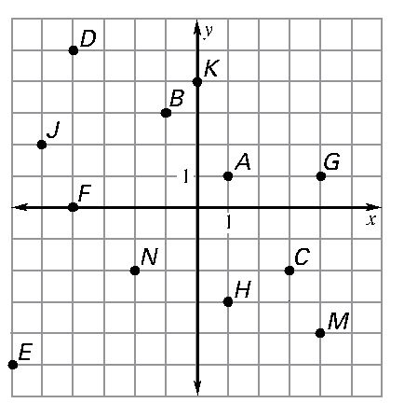
40. A
41. B
42. C
43. D
44. E
45. F
46. H
47. J
48. K
49. M
50. N

Plot each point on the coordinate plane to the right.
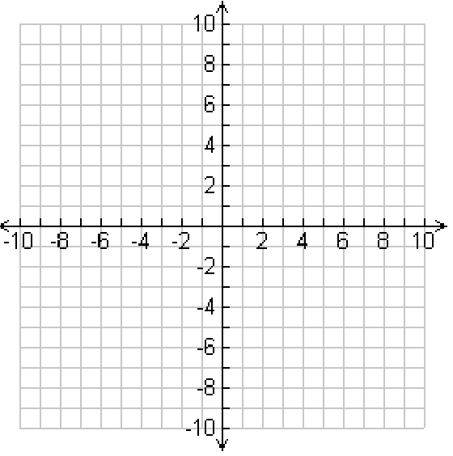
52. $A\left(-2,1\right)$
53. $B \left(2,-2\right)$
54. $C\left(0,-4\right)$
55. $D\left(2, 0\right)$
56. $E\left(-5, -3\right)$
57. $F(1, 3)$

Week 6 Probability and Statistics

Find the probability of the following events occurring.
58.
- Rolling a 4 on a number cube

- Flipping a coin and landing on heads

- Rolling an odd number on a number cube

Create a tree diagram using the options below:
59.
Main Course | Dessert
Chicken Nuggets | Brownie
Hamburger | Cookie
Pizza

60. Find the mean, median, mode, and range of the following test scores:

70, 35, 55, 80, 90, 88, 71, 70, 100, 82

Mean: Median:

Mode: Range:

Week 7 – Getting to know you

61. What part of this packet did you find easy to complete? __________________________________________________________________________________________________________________________________________________________________________

62. Were there any parts that were difficult for you? If so, what?

__________________________________________________________________________________________________________________________________________________________________________
63. What is something you enjoyed about math in sixth grade?
__________________________________________________________________________________________________________________________________________________________________________
64. What is something you disliked about math in sixth grade? __________________________________________________________________________________________________________________________________________________________________________
65. How confident are you that you are ready for math 7?
__________________________________________________________________________________________________________________________________________________________________________

