Rising Math 8 Summer Assignment

Name: _____________________________________________________________________________

Please complete this work over summer and return to your Math 8 teacher the first week of class.

Try to complete a little each week.

SHOW ALL YOUR MATHEMATICAL THINKING!

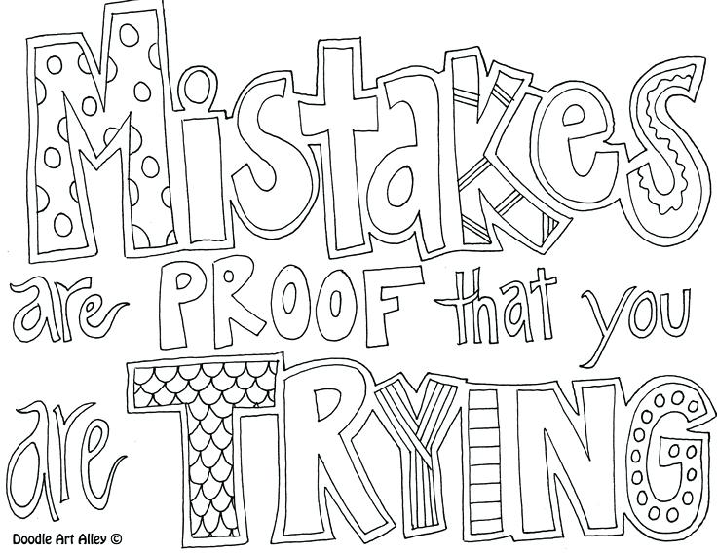

The websites below offer tutorials, practice, and quizzes for review:

<http://www.regentsprep.org>

<http://www.math.com>

<https://www.mathgoodies.com/lessons>

<http://education.jlab.org/solquiz/>

<https://www.khanacademy.org/math/cc-seventh-grade-math>

Week 1 - Expressions

*Evaluate each expression for the given values of the variables.*

1. What is the value of when ?
2. Simplify  when ?
3. What is the value of 5a + 3b when a = 4 and b = 3?

#### *Simplify the following expression using the correct order of operations (GEMDAS).*

1. Simplify: 
2. Simplify: 
3. Simplify: 

Week 2 – Scientific Notation & Proportions

*Express each number either in standard form or in scientific notation.*

1. Write the standard decimal notation for.
2. Write the standard decimal notation for .
3. Write the scientific notation for .008569.
4. Write the standard notion for 10,569,000.

*Solve the following problems. Show all your steps.*

1. Alex and Sam are taking a trip. They measured the distance they will travel on a map. The distance was 4.25 inches. The scale on the map is 1 inch to 50 miles. How many miles will they travel?
2. Jackie is reviewing a blue print for her new house. The scale for the blueprint is 1 in. to 8 ft. Her bedroom is 2.25 in by 1.5 in. on the blueprint. What are the actual dimensions of the blueprint?
3. Kailyn is making lemonade. The directions call for 2 scoops of lemonade mix for every 8 cups of water. How much lemonade mix should she use for 20 cups of water?
4. What is a correct representation of  as a decimal and as a percent?
5. Four-fifths of the students in Mrs. Ramirez’s class attended the Spring Dance. The class has 28 students. Write an expression to represent the number of students who attended the dance.

Week 3 – Real Numbers & Percentages

1. Order these numbers from least to greatest.

35%, **.**4, , 2.3

1. Graph  on the number line.

-7 –6 –5 –4 –3 –2 –1 0 1 2 3 4 5 6 7 8

1. Graph  on the number line.

-7 –6 –5 –4 –3 –2 –1 0 1 2 3 4 5 6 7 8

1. Kelly went to lunch. The bill was $10.75. She left a 15% tip. What was the total cost of lunch?
2. Mrs. Martin purchased a computer that was originally priced at $1,500. It was on sale for 15% off. The sales tax was 7.5%. What was the total cost of the computer?
3. Sarah receives a $1.25 in change from a $10 bill. What percentage of the $10 did she receive in change?

Week 4 - Statistical Representations

1. Make a frequency table to organize the data. 
2. Marin collected data regarding the ages of people at a recent movie. Use a histogram to display Marin’s data. 
3. Find the mean of the following set of numbers? 
4. Find the median, mode, and range of the following set of numbers? 
5. Make a stem-and-leaf plot to display the data set.



Week 5 - Equations

*Solve each equation.*

1. 
2. 
3. 
4. 
5. 
6. 

Week 6 –Measurement & Functions

1. What is the approximate volume of the cylinder? Let =3.14.

1.2 cm

5 cm

1. What is the volume of the prism?

1 cm

2.7 cm

6 cm

Graph the following equations on a coordinate plane.

1. 
2. 
3. 







Week 7 – Functions & Probability

*Graph the following ordered pairs*.

38.



|  |  |
| --- | --- |
| *x* | *y* |
| -2 | -1 |
| -1 | 1 |
| 0 | 3 |
| 1 | 5 |
| 2 | 7 |

39.



|  |  |
| --- | --- |
| *x* | *y* |
| -2 | 5 |
| 0 | 1 |
| 1 | -1 |
| 3 | -5 |
| 4 | -7 |

40. There are 8 cashew, 15 peanuts, 7 almonds, and 5 pecans in a bag. One nut is chosen at random from the bag. What is the probability that it is a pecan?

41. In the figure below, what are the percent, the fraction, and the decimal representations for the area **NOT** shaded?

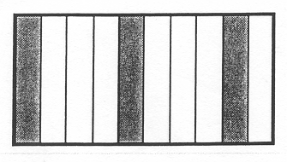

42. How confident are you that you are ready for Math 7 Honors?